Kaplan Higher Education Academy

ICT396 Human Interface Design
Due Friday of Week 11

Assignment – Prototype Travel Planner

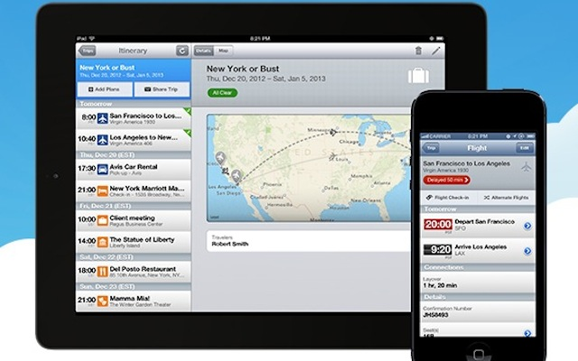

For this assignment, you are to submit a working prototype of the travel planner that we have been working toward in tutorials this semester, plus a report of not more than 4000 words describing it and explaining how to use it.

The Prototype

This prototype may be in the form of a paper or cardboard mockup (as described in Prototyping for Tiny Fingers by M. Rettig and the Topic 6 tutorial on the LMS website) or else as a wireframe or prototype software application (such as Pencil Project, iPhone Mockup - see https://speckyboy.com/2011/02/23/10-completely-free-wireframing-and-mockup-tools/) provided that it can be easily obtained and run by those marking it. Check with your lecturer if you are not sure.

Since a working travel planner might include very many possible functions, you should restrict your prototype to one or two important functions, and do a thorough job of representing those. That is, it should be a vertical prototype, for studying functions in depth.

The prototype should represent a stage of development that is some way along (that is, beyond the first cycle around the 4-step process) and should be more than a series of drawings of screens. Although the prototype need not really implement complicated functions of the travel planner - it is only a model of the interface, not the software, remember - marks will be awarded for working parts of the interface screens themselves (buttons that do something, screens that change, realistic dials or maps, etc.). This is even possible with paper prototypes (see the Rettig paper). Further marks will be awarded for the attractiveness, intuitiveness and creativity of your design.

The Report

Your report submission should use the Word template provided on the unit website and include the following sections:

a. Properly filled in and signed cover sheet

b. Description of the prototype, identifying the functions it covers.

c. Clear instructions on how to use the prototype to experience the interface.

e. Discussion on your experience in building the application, and your observations of others using it. What did you learn from doing this? What’s the value of a paper mockup? A GUI interface tool? What would you do the same, or differently if you needed to do this in your next job? Would you develop more than one prototype travel planner, or more than one kind of prototype or both?

f. References to any written work, tool or software you have used.

g. Mark your own work. That’s right, put your own suggested marks in the Grading Sheet at the bottom of the report template! Don’t worry, this will be corrected if you get it wrong!

Submission

Your submission must display a professional level of layout, presentation and reference citation and should total no more than 4000 words.

Submit your completed report as a Word file via the unit website. Do not convert the file to a pdf or any other format.

If your mockup is a software file, you may submit that by placing it in a folder with the report, compressing the folder into a single .zip file and submitting that (100MB maximum).
If your mockup is a physical cardboard or paper, it may be put into an envelope and handed to your instructor. Please ensure your name and student number is on this. It should arrive no later than the due date.

Extensions If you believe that you will be unable to submit by the due date you must request, in writing, an extension at least one week before the due date from the Unit Coordinator. A good reason must be documented such as illness with a doctor's certificate. Unless you have specific approval for an extension, overdue work may attract a late penalty.

Backup Copy It is the student's responsibility to keep a copy of all project and practical exercise work. This is in any event good computing practice. Extensions may not be granted due to problems of computer systems and loss of data due to disk corruption, loss of work, etc.

Students are strongly warned against plagiarism, collusion and other forms of cheating. You should familiarise yourself with the rules concerning misconduct in submission of assessable work. The University regards very seriously and students in found breach would be subject to disciplinary action by the Division. Horrible, but true. For guidelines on how to avoid plagiarism see http://our.murdoch.edu.au/Student-life/Study-successfully/Referencing-and-citing/How-to-avoid-plagiarism/

